Name: 2015 AOCMF—Basiskurs für Ärzte mit praktischen Übungen, Germany, Tübingen
DPY No.: 107046.01
Place/ Date: 24-26 09 Tübingen

1. JnJ approved location:
2. Venue(look): university
3. Accommodation(look-price-limit):
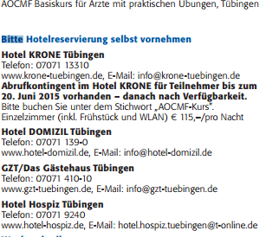

4. Faculty ratio
5. Financials AO 9330 - 2 int faculty ok
14000/40/3= 116
6. Social activity/Dinner(price-limit): 52 chf - ok
7.Program: y
